|  |  |  |  |  |  |  |  |  |  |
| --- | --- | --- | --- | --- | --- | --- | --- | --- | --- |
|  | | | | | | | | | |
|  | Report on Lab-10  DATABASE MANAGEMENT SYSTEMS LAB | | | | | |  | |
|  |  | | | | | | |  | | |
| Submitted by  Adid-Al-Mahamud Shazid  Student Id: 210042172  Department: CSE  Programme: SWE  Course Title: CSE 4308  Submitted to  Zannatun Naim Sristy  Lecturer, Department of CSE  November 15, 2023 | |  | | | | |
|  |
|  | | |  |
|  | |  | | | |  | | | |

**Introduction**

In the lab class, we were given task to perform command on PL/SQL.

**Task 1**

(a) Print your name.

(b) Take your student ID as input and print its length.

(c) Take two numbers as input and print their product.

(d) Print the current system time in 12-hour format.

(e) Take a number as input and print whether it is a whole number or a fraction.

(f) Write a procedure that takes a number as an argument and prints whether it is a composite number or not.

* 1. **Solution**

SET SERVEROUTPUT ON SIZE 1000000;

SET VERIFY OFF;

--a--

BEGIN

DBMS_OUTPUT.PUT_LINE('Adid Al Mahamud Shazid');

END;

/

--b--

DECLARE

ID VARCHAR2 (20);

BEGIN

ID := '&Student_Id';

DBMS_OUTPUT.PUT_LINE('Student Id Length: ' || LENGTH(ID));

END ;

/

--c--

DECLARE

Num1 NUMBER;

Num2 NUMBER;

Numsum NUMBER;

BEGIN

Num1 := '&Num1';

Num2 := '&Num2';

Numsum := Num1+ Num2;

DBMS_OUTPUT.PUT_LINE( 'Sum= ' || Numsum);

END ;

/

---d--

DECLARE

nowTime TIMESTAMP;

BEGIN

nowTime:= SYSTIMESTAMP;

DBMS_OUTPUT . PUT_LINE ('Current Time: ' || TO_CHAR ( nowTime, 'HH :MI:SS AM'));

END ;

/

--e--

DECLARE

Num1 NUMBER;

BEGIN

Num1 := '&Number';

IF MOD(num1,1) = 0

THEN DBMS_OUTPUT.PUT_LINE( Num1 || ' is a Whole Number');

ELSE

DBMS_OUTPUT.PUT_LINE( Num1 || ' is a Fraction');

END IF;

END ;

/

--f--

CREATE OR REPLACE

FUNCTION Check_Composite (num NUMBER)

RETURN BOOLEAN

IS

BEGIN

IF (num <= 1)

THEN RETURN FALSE;

END IF;

FOR i IN 2..ROUND(SQRT(num)) LOOP

        IF MOD(num, i) = 0 THEN

            RETURN TRUE;

        END IF;

    END LOOP;

RETURN FALSE;

END ;

/

-- Call it from an anonymous block

DECLARE

num NUMBER;

res BOOLEAN;

BEGIN

num:= '&number';

res:= Check_Composite(num);

IF res

THEN DBMS_OUTPUT.PUT_LINE(num || ' is Composite');

ELSE DBMS_OUTPUT.PUT_LINE(num || ' is Prime');

END IF;

END ;

/

* 1. **Analysis and Explanation**

The task was given to getting familiar with the PL/SQL basic commands.

* 1. **Difficulties**

I did not face any difficulties when doing this task as all of the guidelines I got from the PL/SQL notes file.

* 1. 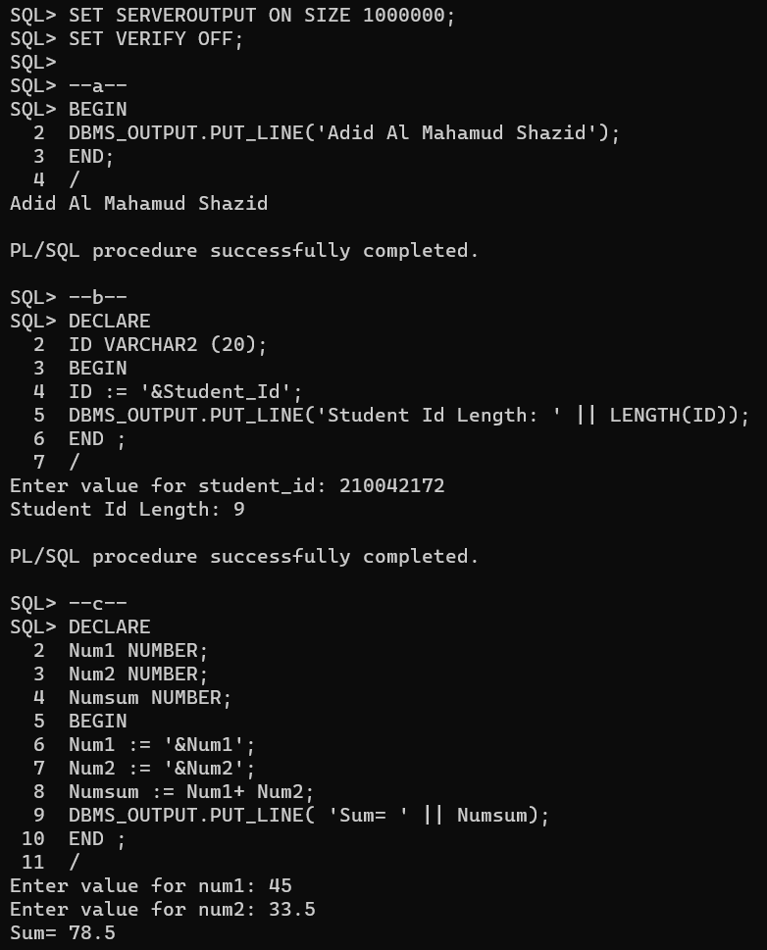**Output**

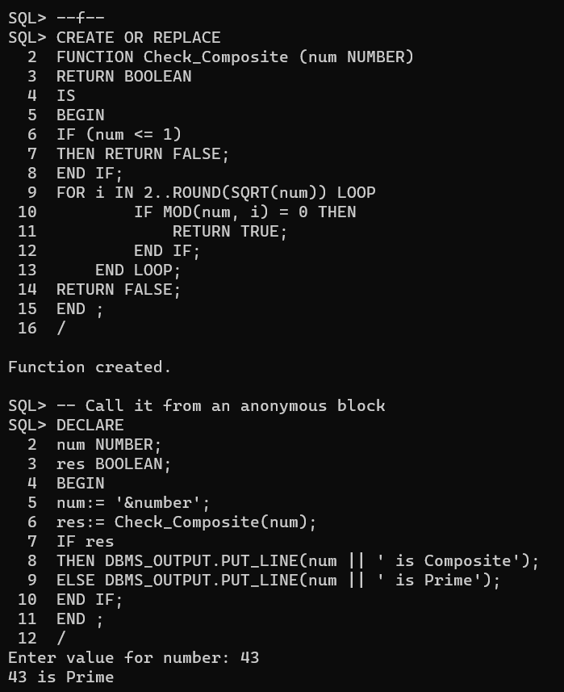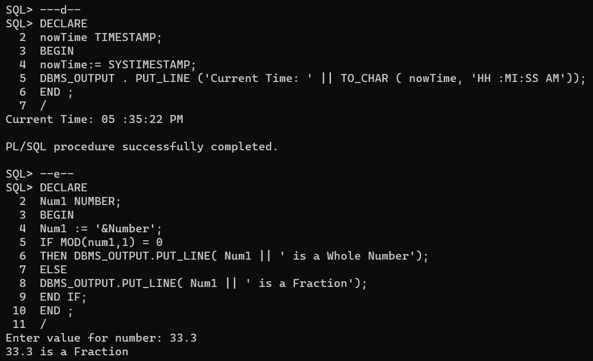

**Task 2**

Execute the provided “movie.sql” file and answer the following questions:

(a) Write a procedure to find the N top-rated movies and their details (Top-rated means top highest average rating). The procedure will take N as input and print the details up to N movies. If N is greater than the number of movies, then it will print an error message.

(b) Write a function to find the movie status (“Solo”, “Ensemble”). If the total number of actors/actresses in a movie is 1, then the status should be “Solo”, else it should be “Ensemble”. The function will take the title of the movie as input as input and return the status.

(c) Write a procedure to find the possible nominees for the Oscars. A director is eligible for an Oscar if at least one of their movies has an average rating of at least 7. Also, the movie should be reviewed by more than 10 reviewers.

(d) Write a function that will take the title of the movie as input and find the movie category based on Table 1.

* 1. **Solution**

--a--

-- Procedure to Find N Top movie rating

CREATE OR REPLACE PROCEDURE Top_Movies(N IN NUMBER) IS

    movie_count NUMBER;

  BEGIN

    SELECT COUNT(*)

    INTO movie_count

    FROM Movie;

    IF N > movie_count THEN

        DBMS_OUTPUT.PUT_LINE('Error: Overflow');

        RETURN;

    END IF;

    movie_count := 0;

    FOR movie_rating IN (

        SELECT m.mov_id, m.mov_title, NVL(AVG(r.rev_stars),0) as avg_rating

        FROM Movie m LEFT JOIN Rating r ON m.mov_id = r.mov_id

        GROUP BY m.mov_id, m.mov_title

        ORDER BY avg_rating DESC

    )

    LOOP

        DBMS_OUTPUT.PUT_LINE('Movie ID: ' || movie_rating.mov_id);

        DBMS_OUTPUT.PUT_LINE('Title: ' || movie_rating.mov_title);

        DBMS_OUTPUT.PUT_LINE('Average Rating: ' || ROUND(movie_rating.avg_rating, 2));

        DBMS_OUTPUT.PUT_LINE('------------------------');

        movie_count:= movie_count + 1;

        EXIT WHEN movie_count>= n;

    END LOOP;

END;

/

-- Call it from an anonymous block

DECLARE

    N NUMBER;

BEGIN

    N:= '&N';

    Top_Movies(N);

END;

/

-- b--

CREATE OR REPLACE

FUNCTION movie_Status (movie_title VARCHAR2)

RETURN VARCHAR2

IS

act_count NUMBER;

BEGIN

SELECT COUNT(c.ACT_ID) INTO act_count

FROM MOVIE m LEFT JOIN CASTS c ON m.MOV_ID= c.MOV_ID

GROUP BY m.MOV_ID, m.MOV_TITLE

HAVING m.MOV_TITLE = movie_title;

IF act_count= 0 THEN

    RETURN 'No actor Found';

ELSIF act_count= 1 THEN

    RETURN 'Solo';

ELSE

    RETURN 'Ensemble';

END IF;

END ;

/

DECLARE

    title VARCHAR2(100);

BEGIN

    title:= '&title';

    DBMS_OUTPUT.PUT_LINE(movie_Status(title));

END;

/

--c--

-- Procedure for Oscar Nominees

CREATE OR REPLACE PROCEDURE Find_Oscar_Nominees

IS

    nominee_count NUMBER := 1;

BEGIN

    FOR nominee_names IN (

        SELECT DISTINCT d.DIR_FIRSTNAME || ' ' || d.DIR_LASTNAME AS NOMINEE_NAME

        FROM DIRECTOR d

        LEFT JOIN DIRECTION dir ON d.DIR_ID = dir.DIR_ID

        WHERE dir.MOV_ID IN (

            SELECT m.MOV_ID

            FROM MOVIE m

            LEFT JOIN RATING r ON m.MOV_ID = r.MOV_ID

            GROUP BY m.MOV_ID

            HAVING COUNT(r.REV_ID) > 10 AND AVG(r.REV_STARS) >= 7

        )

    )

    LOOP

        DBMS_OUTPUT.PUT_LINE('Nominee ' || nominee_count || ': ' || nominee_names.NOMINEE_NAME);

        nominee_count := nominee_count + 1;

    END LOOP;

END Find_Oscar_Nominees;

/

-- Call it from an anonymous block

BEGIN

    Find_Oscar_Nominees;

END;

/

--d--

CREATE OR REPLACE FUNCTION movie_Category (movie_title VARCHAR2)

RETURN VARCHAR2

IS

    release_year NUMBER;

    avg_rating NUMBER;

BEGIN

    SELECT m.mov_year, NVL(AVG(r.rev_stars), 0)

    INTO release_year, avg_rating

    FROM Movie m LEFT JOIN Rating r ON m.mov_id = r.mov_id

    WHERE m.MOV_TITLE = movie_title

    GROUP BY m.mov_id, m.mov_title, m.mov_year;

    IF (release_year >= 1950 AND release_year <= 1959 AND avg_rating > 6.5) THEN

        RETURN 'Fantastic Fifties';

    ELSIF (release_year >= 1960 AND release_year <= 1969 AND avg_rating > 6.7) THEN

        RETURN 'Sweet Sixties';

    ELSIF (release_year >= 1970 AND release_year <= 1979 AND avg_rating > 6.9) THEN

        RETURN 'Super Seventies';

    ELSIF (release_year >= 1980 AND release_year <= 1989 AND avg_rating > 7.1) THEN

        RETURN 'Ecstatic Eighties';

    ELSIF (release_year >= 1990 AND release_year <= 1999 AND avg_rating > 7.3) THEN

        RETURN 'Neat Nineties';

    ELSE

        RETURN 'Garbage';

    END IF;

END;

/

DECLARE

    title VARCHAR2(100);

BEGIN

    title:= '&title';

    DBMS_OUTPUT.PUT_LINE(movie_Category(title));

END;

/

* 1. **Analysis and Explanation**

Here I had to run advance queries to make procedures and Functions for PL/SQL.

* 1. **Difficulties**

The major difficulty I faced is I got compilation error so many times and it was so hard to identify the problem as I had to give input in a whole block which contains several lines.

* 1. 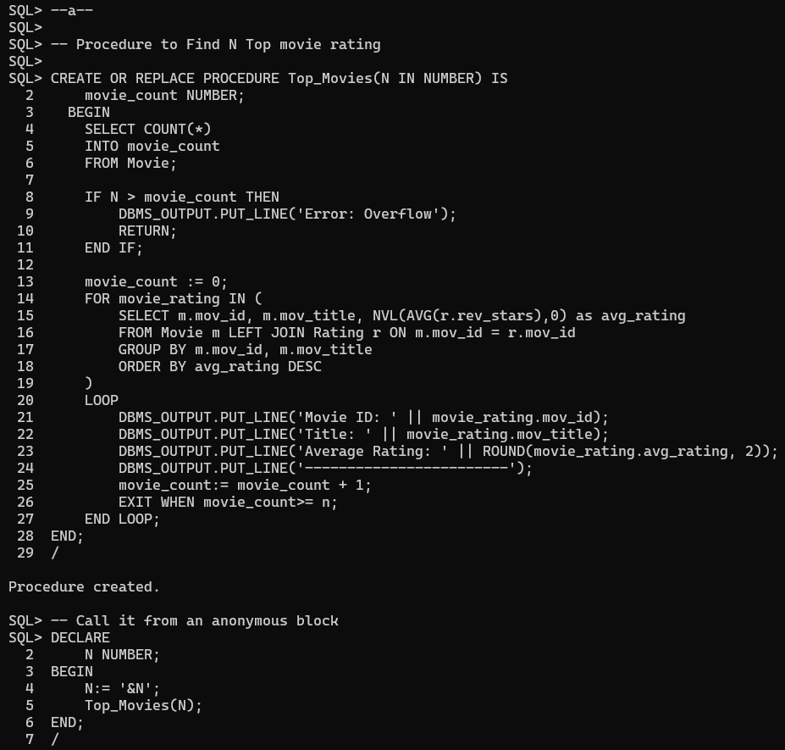**Output**

